# Specific Learning Difficulties Cover Note

**Student ID:** 150402149

**Advice for assessors and examiners**

Guidelines for markers assessing coursework and examinations of students diagnosed with Specific Learning Difficulties (SpLDs) –

As far as the learning outcomes for the module allow, examiners are asked to mark exam scripts sympathetically, ignoring the types of errors that students with SpLDs make and to focus on content and the student’s understanding of the subject.

Specific learning difficulties such as Attention Deficit Disorders, dyslexia and or dyspraxia may affect student performance in the following ways:

* The candidate’s spelling, grammar and punctuation may be less accurate than expected
* The candidate’s organisation of ideas may be confused, affecting the overall structure of written work
* The candidate’s proof reading may be weak with some errors undetected, particularly homophones and homonyms which can avoid spell checkers

**Under examination conditions, these difficulties are likely to be exacerbated. Errors are likely to become more marked towards the end of scripts.**

Useful approaches can include:



* Reading the passage quickly for content
* Including positive/constructive comments amongst the feedback so that students can work with specialist study skills tutors on developing new coping strategies
* Using clear English and when correcting; explain what is wrong and give examples
* Using non-red coloured pens for comments/corrections

**Colleagues in schools are asked to ensure that students with specific learning difficulties access the support provided by the** [Disability and Dyslexia Service](http://www.dds.qmul.ac.uk/about/index.html)**.**

For more information regarding marking guidelines see DDS webpage



http://www.dds.qmul.ac.uk/staffinfo/index.html and the [Institutional Marking Practices for Dyslexic Students](http://adshe.org.uk/wp-content/uploads/marking_guidelines_for_good_practice.docx)

**Disability and Dyslexia Service**

Student Services

Room 2.06 Francis Bancroft Building

[www.dds.qmul.ac.uk](http://www.dds.qmul.ac.uk/)

Tel: 020 7882 2756

Email: dds@qmul.ac.uk

### Alteration or misuse of this document will result in disciplinary action

Natural Language Processing Lab 3

**Part A. Generative Grammars**

**1.**

1. I want a flight

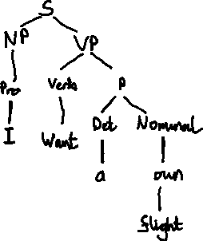

2. I want a morning flight

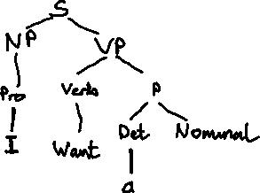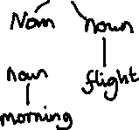

3. I want a flight in the morning

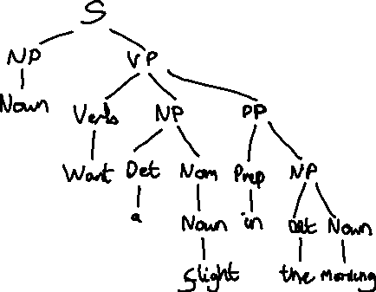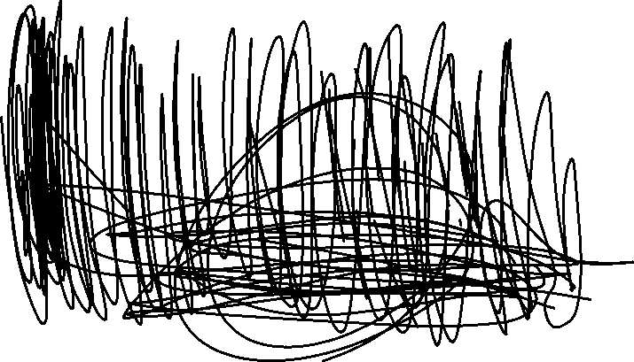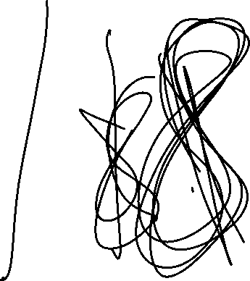

**2.**

1. I want a flight in the morning from Baltimore

VP -> Verb NP PP PP

2. I want a flight from Baltimore to Los Angeles

VP -> Verb NP PP PP

3. I need a trip in the morning from Baltimore to Los Angeles

VP -> Verb NP PP PP PP

**3.**

1. Do you have a flight in the morning?



2. What flights do you have?



**4.**

The two needed new rules are:  
NP -> Adj Noun

Adj -> Adj Adj

1. direct flight



2. first direct flight



3. first non-stop direct flight



**5.**

NP -> Proper-Noun possessiveMorpheme

Lexicon

possessiveMorpheme -> ‘s

**Part B. Logical Grammars**

**1.**

1. John



2. John and Mary

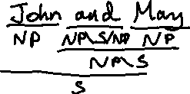

3. John slept

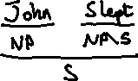

4. John slept and snored

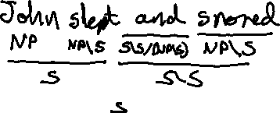

5. John and Mary slept

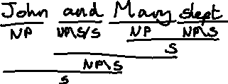

6. John and Mary slept and snored

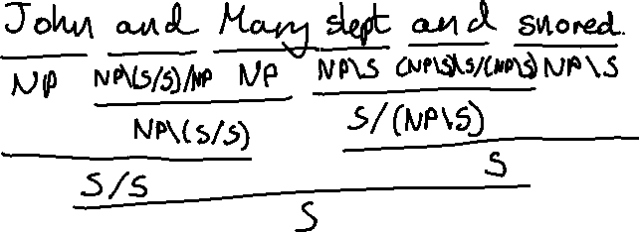

7. John ate pizza

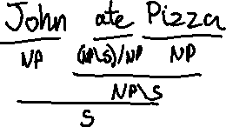

8. John and Mary ate Pizza and Pasta

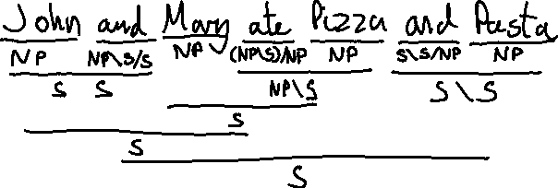

**2.**

Big = NP/NP

1. Big John

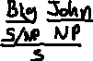

2. Big John slept

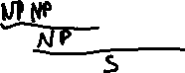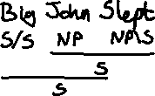

3.Big John ate Pizza

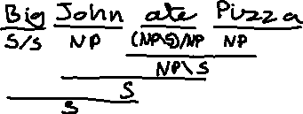

4. Big John and Mary

And = NP\S/NP

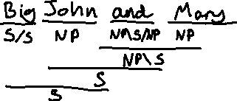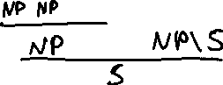

**3.**

Big | Who Q/S

1. Did John sleep

2.

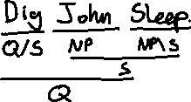

2. Did John eat Pizza

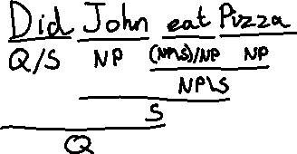

Natural Language Processing Lab 4

Part A. Dependency Grammars

**1.**

1. I want a flight

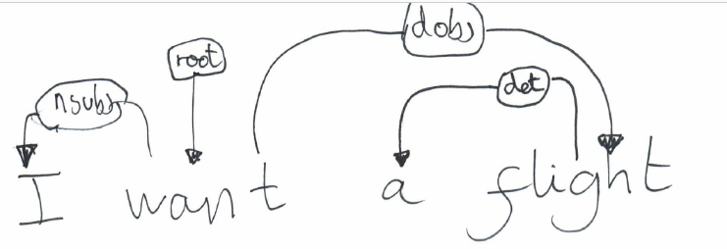

2. I want a morning flight

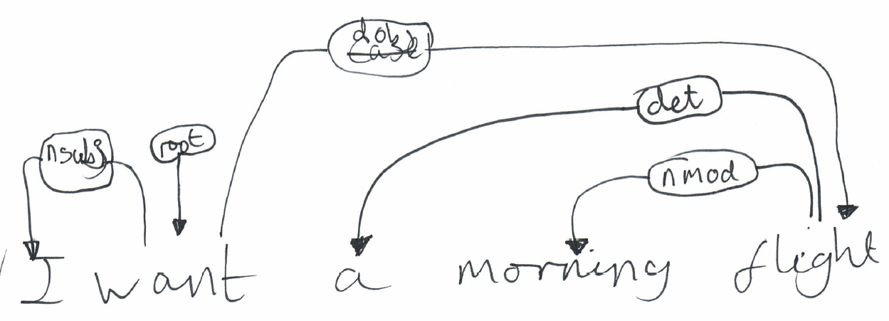

3. I want a flight in the morning



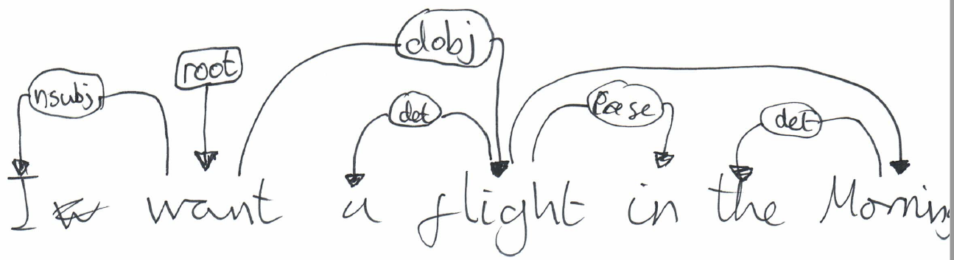



4. I want a flight in the morning from Boston

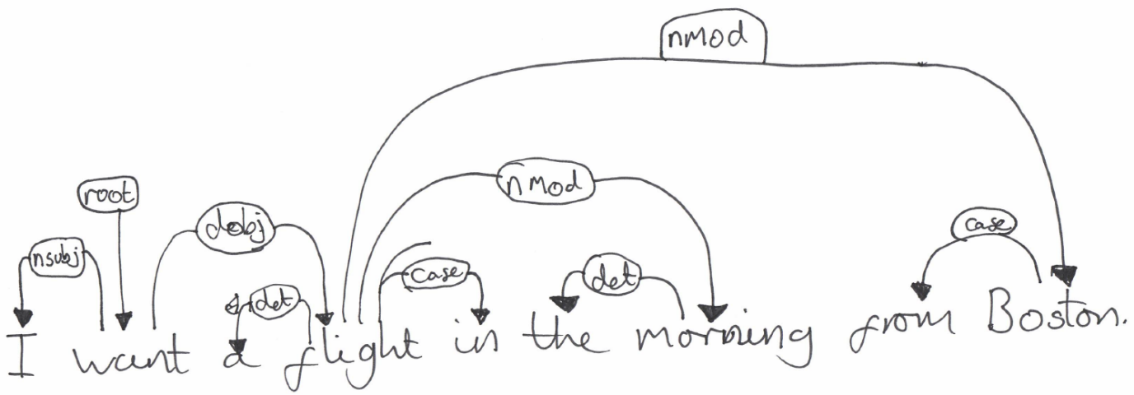

**2.**

1. I want from you a flight in the morning

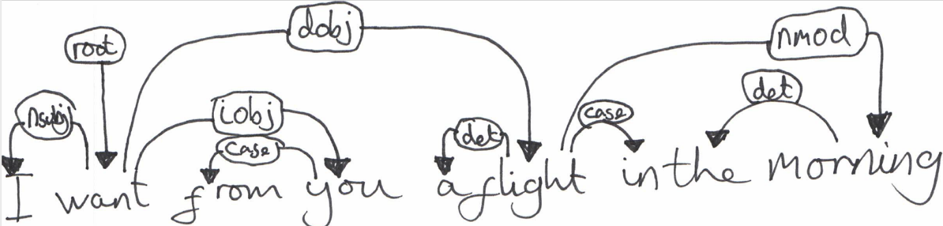

2. I want from Boston a flight in the morning

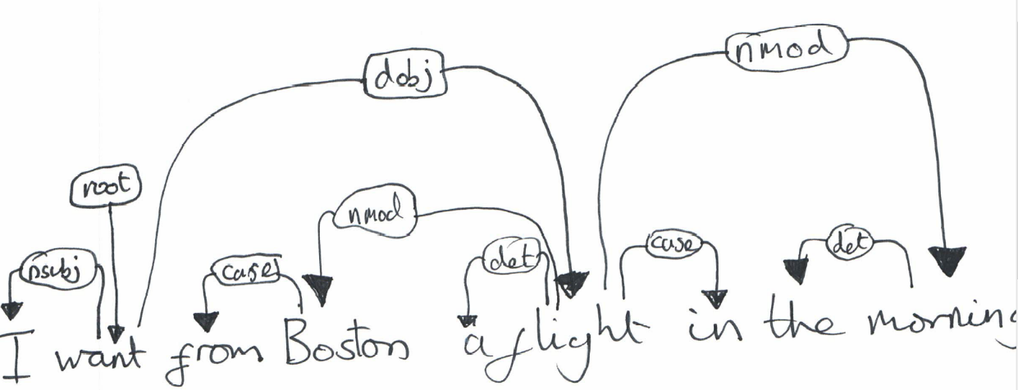

3. I want a flight in morning the

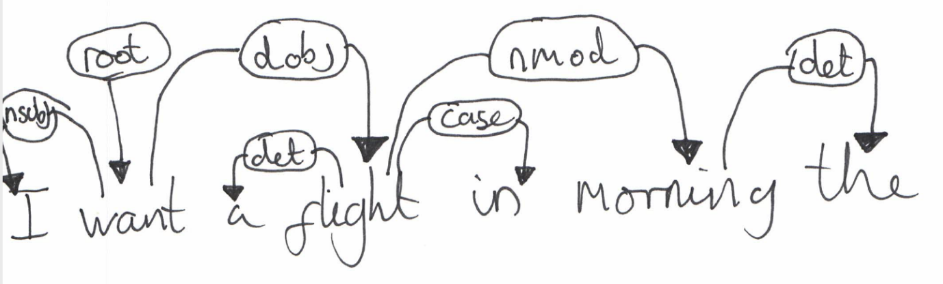

This graph contains no non projective arcs. All arcs can reach every word between the start and end of the arc. This sentence is a variant of the last sentence in question 1 with the ‘the’ switched with ‘morning’ however this doesn’t make the graph non projective.



**3.**

1. John and Mary booked the first direct flight and slept

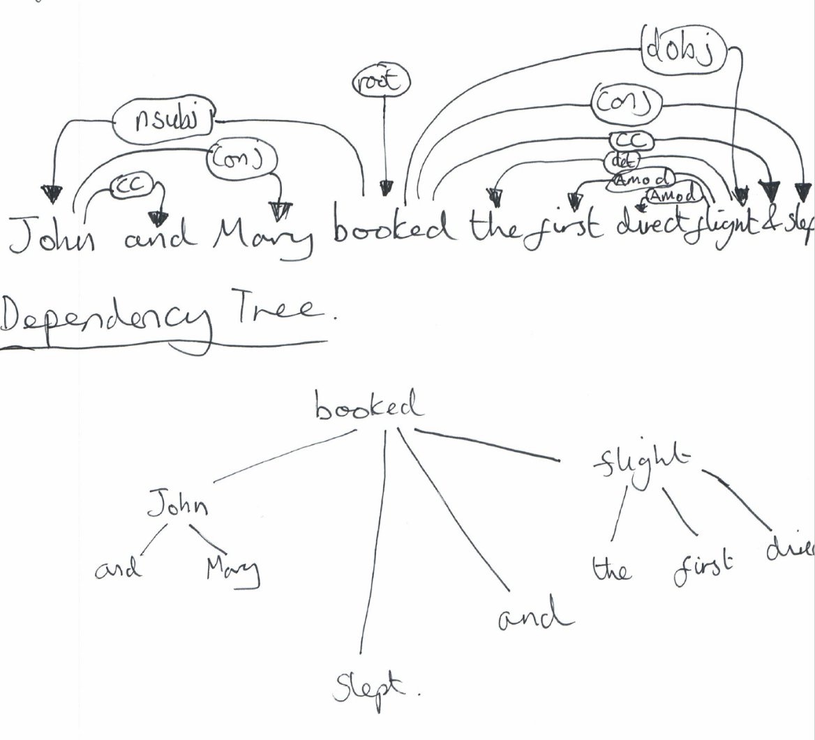

**Part B. CKY Parsing with Context Free Grammars.**

1. Chompsky Normal form Production Rules

|  |
| --- |
| Production Rules |
| S → VP X1  X1 → NP PP  S → VP NP  PP → *Prep* NP  PP → PP PP  NP → *Det* *Noun*  NP → NP PP  NP → *Det* Y1  Y1 → AP *Noun*  AP → *Adj* AP  AP → *big* | *small* | *red* | *yellow*  Prep → *in* | *behind*  Det → *the* | *a*  Noun → *ball* | *hat* | *banana* | *apple*  VP → *Put* | *take* |

1. Parse ‘Take the big yellow banana’ using the new production rules

|  |  |  |  |  |
| --- | --- | --- | --- | --- |
| **Take** | **the** | **big** | **yellow** | **banana** |
| **VP,Verb**  **[0,1]** | **[0,2]** | **[0,3]** | **[0,4]** | **S**  **[0,5]** |
|  | **Det**  **[1,2]** | **[1,3]** | **[1,4]** | **NP**  **[1,5]** |
|  |  | **AP,Adj**  **[2,3]** | **AP**  **[2,4]** | **Y1**  **[2,5]** |
|  |  |  | **AP,Adj**  **[3,4]** | **Y1**  **[3,5]** |
|  |  |  |  | **Noun**  **[4,5]** |

|  |
| --- |
| Production Rules |
| S → VP X1  X1 → NP PP  S → VP NP  PP → *Prep* NP  PP → PP PP  NP → *Det* *Noun*  NP → NP PP  NP → *Det* Y1  Y1 → AP *Noun*  AP → *Adj* AP  AP → *big* | *small* | *red* | *yellow*  Prep → *in* | *behind*  Det → *the* | *a*  Noun → *ball* | *hat* | *banana* | *apple*  VP → *Put* | *take* |

There is only one parse for this sentence.

**3.**

|  |  |  |  |  |  |  |  |  |  |
| --- | --- | --- | --- | --- | --- | --- | --- | --- | --- |
| **Put** | **The** | **Ball** | **Behind** | | **The** | **Apple** | **In** | **the** | **Hat** |
| **VP,Verb**  **[0,1]** | **[0,2]** | **S**  **[0,3]** | **[0,4]** | | **[0,5]** | **S**  **[0,6]** | **[0,7]** | **[0,8]** | **S,X1**  **[0,9]** |
|  | **Det**  **[1,2]** | **NP**  **[1,3]** | **[1,4]** | | **[1,5]** | **NP,X1**  **[1,6]** | **[1,7]** | **[1,8]** | **NP,NP,X1**  **[1,9]** |
|  |  | **Noun**  **[2,3]** | **[2,4]** | | **[2,5]** | **[2,6]** | **[2,7]** | **[2,8]** | **[2,9]** |
|  | |  | **Prep**  **[3,4]** | | **[3,5]** | **PP**  **[3,6]** | **[3,7]** | **[3,8]** | **PP,PP**  **[3,9]** |
|  |  | | **Det**  **[4,5]** | **NP**  **[4,6]** | **[4,7]** | **[4,8]** | **NP**  **[4,9]** |
|  |  | |  | **Noun**  **[5,6]** | **[5,7]** | **[5,8]** | **[5,9]** |
|  |  | |  |  | **Prep**  **[6,7]** | **[6,8]** | **PP**  **[6,9]** |
|  |  | |  |  |  | **Det**  **[7,8]** | **NP**  **[7,9]** |
|  |  | |  |  |  |  | **Noun**  **[8,9]** |
| Production Rules | | | |
| S → VP X1  X1 → NP PP  S → VP NP  PP → *Prep* NP  PP → PP PP  NP → *Det* *Noun*  NP → NP PP  NP → *Det* Y1  Y1 → AP *Noun*  AP → *Adj* AP  AP → *big* | *small* | *red* | *yellow*  Prep → *in* | *behind*  Det → *the* | *a*  Noun → *ball* | *hat* | *banana* | *apple*  VP → *Put* | *take* | | | |

You can perform 6 full parses from the sentence.

Put the ball  
Put the apple  
Put the hat  
Put the ball behind the apple  
Put the ball in the hat  
Put the ball behind the apple in the hat.